Figures:

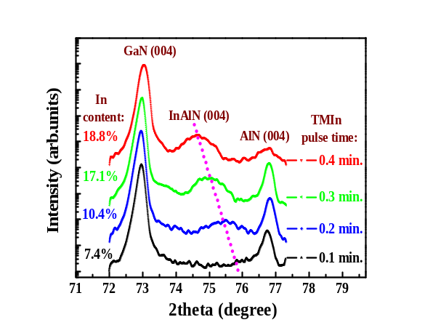
FIG.1. HRXRD (004) plane w-2θ scans of InAlN/GaN heterostructures grown under different TMIn pulse duration

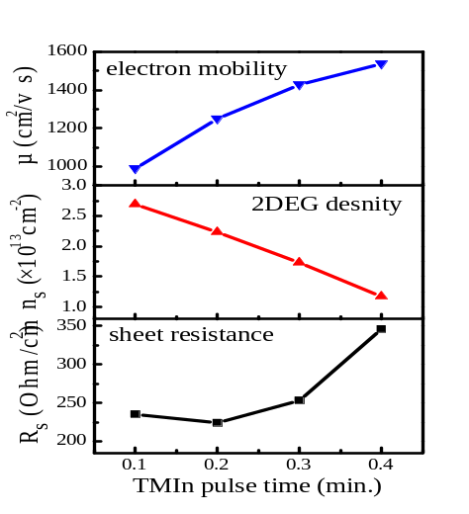
FIG.2 Room temperature Hall mobility (μ), sheet carrier density (n_{s}), and sheet resistance (R_{s}) of PMOCVD-grown InAlN/GaN heterostructures as a function of TMIn pulse duration

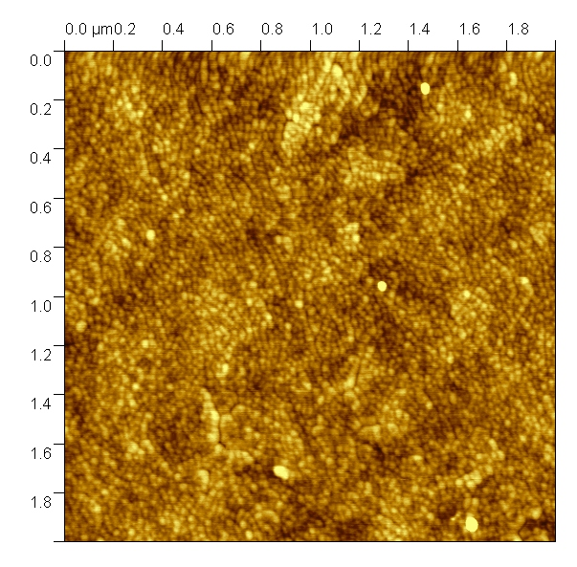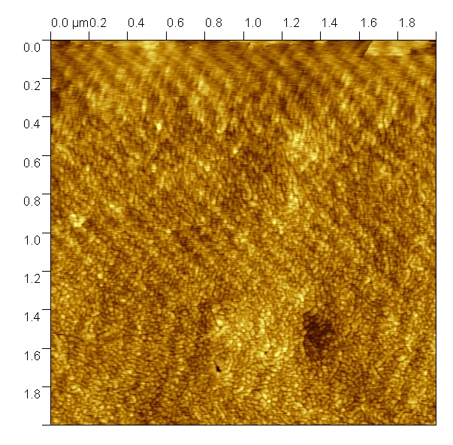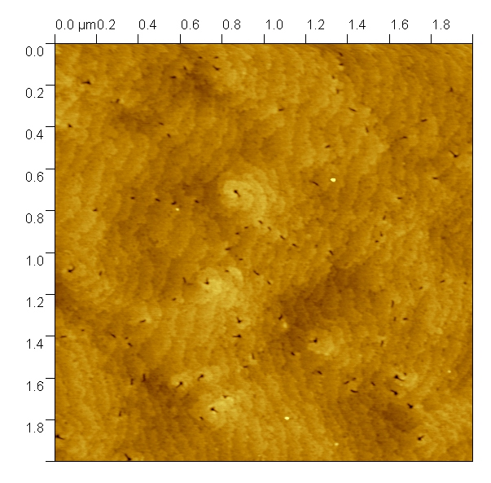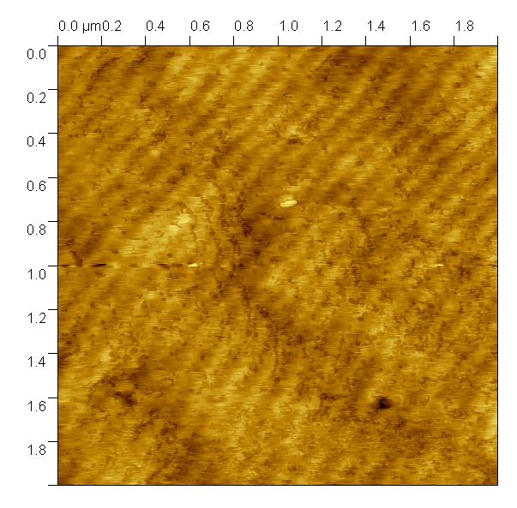
(a)
(b)
(c)
(d)
FIG.3. AFM images of surface morphologies of InAlN/GaN heterostructures grown by PMOCVD under different TMIn pulse duration (a) 0.1 min., (b) 0.2 min., (c) 0.3 min., (d) 0.4 min.

